Mohammad Ali Jinnah University  
Department of Computer Science  
**Final Lab Exam – Spring 2020**

**Subject: Introduction to Computing Section: BM  
Date: 3rd July 2020 Total Marks: 40**

**Read the following instructions carefully before starting your exam:**

* Rename this file as following: **“ITC BM Final - [Your Name] [Student ID]”**
* Type your **Name** and **Student** **ID** in the space provided in the **header section**.
* Attempt all questions.
* You can use any platform for writing your code.
* Copy your code from the IDE and then **paste under the respective question**.
* Also **paste a snapshot** of your output under your code (where required).
* Submit your final exam in **Google Classroom** folder allocated for the final exam.
* All necessary files must be uploaded individually. **DO NOT upload a zipped folder**.
* There will be a maximum of **04 files** to be submitted i.e. Your answer script (This same edited file), your HTML file and CSS files (for Question 3) and HTML file (for Question 4).
* Submit your final exam latest by **4th July, 8:59 am**. **Late submission** for any reason whatsoever, will **NOT BE ACCEPTED**.

Failure in abiding to the above instructions may result in **deduction of marks** or **cancellation of exam**

**Question No. 1: Identify the logical/syntax mistakes and then modify the following codes to achieve the given objective:**

1. The objective is to keep calculating the product of positive integers until the user presses ‘0’ (ZERO).

**( ___ / 6 marks)**

**Code:**

num = input("Enter the number")

num1 = 0

while(num > 2):

num1 = num1 * num

#avg = num1/count

print("product: ", num1)

num = int(input("Enter the number"))

print("Final Product:", num1)

**Add your modified code in the following space:**

**value = int(input("Enter the number"))**

**n = 1**

**while(value > 0):**

**n = n * value**

**print("your product: ", n)**

**value = int(input("Enter the number"))**

**print("Final Product:", n)**

1. The following code prints a triangle of a fixed size. Using suitable control structures, modify the code so that it can print a rectangle with any character and size based on the user input.

**( ___ / 4 marks)**

**Code:**

char = "*"

for i in range (0,10):

print(char*i)

**Add your modified code in the following space:**

**def rectangula_pattern(a,b) :**

**if(a==b):**

**print("Its a square not rectangular :) ")**

**else:**

**for i in range(0,a):**

**for j in range(0,b):**

**print("*", end="")**

**print()**

**row= int(input("Enter the range of row: "))**

**col = int(input("Enter the range of column: "))**

**rectangula_pattern(row,col)**

**Question 2:** Write a function that asks the user to enter time in minutes. If the user enters a negative value, the program should tell the user that the entry is invalid. Otherwise, the program should convert the time value to seconds and print out the result. There are 60 seconds in 1 minute.

**( ____ / 5 marks)**

**Add your code here:**

**def time_minute():**

**minute = int(input("Enter time in minute : "))**

**second = minute*60**

**if(minute > 0):**

**print(second,"second")**

**else:**

**print("Entry is invalid.")**

**time_minute()**

**Paste a snapshot of your code’s output here:**

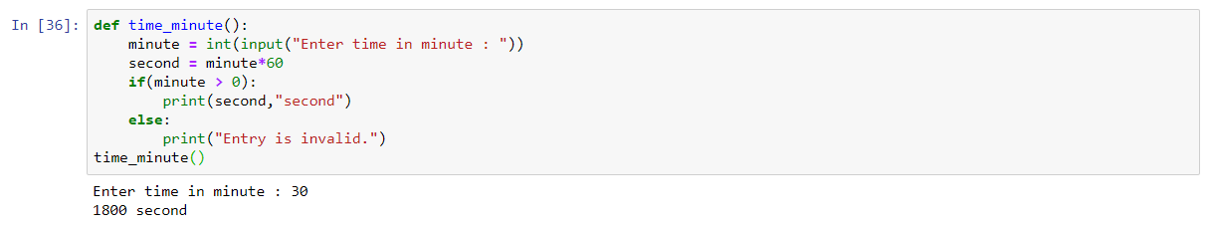

**Question 3:** Create a webpage showing the top 10 Countries most affected by Covid-19 . Use external CSS for styling. The page should have the following characteristics:

**( ____ / 10 marks)**

1. The country name
2. Country’s flag image (When you click on the image, it should direct to the page from where you added the flag)
3. 2 to 4 line description of country’s COvid-19 situation.
4. At least one link to a website from where you gathered the information
5. Use an image related to covid-19 as a background
6. All images must be added through link from the website. DO NOT download images and create folders.
7. Submit your HTML file separately along with this answer script.

**Copy your HTML Code here:**

**<!DOCTYPE html>**

**<html>**

**<head>**

**<link rel="stylesheet" type="text/css" href="Question03.css">**

**</head>**

**<body>**

**<center><h1 class="Heading">COVID-19</h1></center>**

**<table>**

**<tr>**

**<td><center><h1>COUNTRY NAME</h1></td></center>**

**<td><center><h1>COUNTRY FLAG</h1> </td></center>**

**<td><center><h1> INFORMATION</h1></td></center>**

**</tr>**

**<tr>**

**<td><h2>USA</h2></td>**

**<td><a target="_blank" href="https://www.worldometers.info/coronavirus/country/us/">**

**<img src="https://www.worldometers.info/img/flags/small/tn_us-flag.gif">**

**</a>**

**</td>**

**<td>**

**<p>**

**The Department of State is taking decisive action to inform and safeguard U.S. citizens overseas, protect the homeland, advance the Administration’s commitment to building global health security capacity for this and future outbreaks, and reduce the impact for U.S. companies and supply chains overseas.**

**</p></td>**

**</tr>**

**<td><h2>BRAZIL</h2></td>**

**<td><a target="_blank" href="https://www.worldometers.info/coronavirus/country/brazil/">**

**<img src="https://www.worldometers.info/img/flags/small/tn_br-flag.gif">**

**</a>**

**</td>**

**<td>**

**<p>**

**the actual total death toll from COVID-19 is likely to be higher than the number of confirmed deaths – this is due to limited testing and problems in the attribution of the cause of death; the difference between reported confirmed deaths and total deaths varies by country**

**the actual number of cases is likely to be much higher than the number of confirmed cases – this is due to limited testing.**

**</p></td>**

**</tr>**

**<td><h2>RUSSIA</h2></td>**

**<td><a target="_blank" href="https://www.worldometers.info/coronavirus/country/russia/">**

**<img src="https://www.worldometers.info/img/flags/small/tn_rs-flag.gif" >**

**</a>**

**</td>**

**<td><p>**

**Federal transport authorities have found more than 500 violations of anti-coronavirus measures at Russian airports in June, the Kommersant business daily reported.Russia's Federal Air Transport Agency, Rosaviatsia, has extended Russia's ban on international flights until Aug. 1 due to the coronavirus, the RBC news website reported and a source at Moscow's Vnukovo Airport confirmed to The Moscow Times.**

**</p></td>**

**</tr>**

**<td><h2>INDIA</h2></td>**

**<td><a target="_blank" href="https://www.worldometers.info/coronavirus/country/india/">**

**<img src="https://www.worldometers.info/img/flags/small/tn_in-flag.gif">**

**</a></td>**

**<td><p>**

**india and Pakistan have experienced their largest single-day increase in coronavirus infections, confirming more than 14,700 cases between them Friday, as the virus shows no sign of peaking in South Asia.**

**Each country now exceeds the number of reported cases from China, where the pandemic originated.**

**India, with the highest coronavirus count in Asia, reported 9,851 additional infections Friday. Its daily tallies are now higher than any country's except for the United States, Brazil and Russia. Neighboring Pakistan reported 4,896 new cases Friday. Its total of 89,249 cases has surpassed China's tally for the first time, with its most populous Punjab province accounting for the largest share of infections.**

**</p></td>**

**</tr>**

**<td><h2>SPAIN</h2></td>**

**<td><a target="_blank" href="https://www.worldometers.info/coronavirus/country/spain/">**

**<img src="https://www.worldometers.info/img/flags/small/tn_sp-flag.gif">**

**</a></td>**

**<td><p>**

**444 new cases and 5 new deaths in Spain. Total Cases' is the sum of total cases detected by PRC and antibodies tests. The discrepancies that may appear with respect to the total case data previously reported are the result of the validation of the same by the autonomous communities and the transition to the new surveillance strategy. This discrepancy could still persist for several days.**

**</p></td>**

**</tr>**

**<td><h2>PERU</h2></td>**

**<td><a target="_blank" href="https://www.worldometers.info/coronavirus/country/peru/">**

**<img src="https://www.worldometers.info/img/flags/small/tn_pe-flag.gif ">**

**</a></td>**

**<td><p>**

**The COVID-19 pandemic in Peru is part of the worldwide pandemic of coronavirus disease 2019 (COVID-19) caused by severe acute respiratory syndrome coronavirus 2 (SARS-CoV-2). The virus was reported to have spread to Peru on 6 March 2020 when a 25-year-old man who had travelled to Spain,**

**France and the Czech Republic tested positive.[1] On 15 March 2020, President Martín Vizcarra announced a country-wide lockdown, closing borders, restricting domestic travel, and forbidding nonessential business operations—excluding health facilities, food vendors, pharmacies, and financial institutions.**

**</p></td>**

**</tr>**

**<td><h2>CHILE</h2></td>**

**<td><a target="_blank" href="https://www.worldometers.info/coronavirus/country/chile/">**

**<img src="https://www.worldometers.info/img/flags/small/tn_ci-flag.gif" >**

**</a></td>**

**<td><p>**

**The number of tests does not refer to the same in each country – one difference is that some countries report the number of people tested, while others report the number of tests (which can be higher if the same person is tested more than once). And other countries report their testing data in a way that leaves it unclear what the test count refers to exactly.**

**</p></td>**

**</tr>**

**<td><h2>United Kingdom (UK)</h2></td>**

**<td><a target="_blank" href="https://www.worldometers.info/coronavirus/country/uk/">**

**<img src="https://www.worldometers.info/img/flags/small/tn_uk-flag.gif">**

**</a></td>**

**<td><p>**

**The UK coronavirus cases surged significantly in the third and fourth weeks of March making it one of the top ten countries with coronavirus.**

**Confirmed coronavirus cases in the UK surged to 5,741 on 23 March and crossed 34,000 on 02 April, while death toll increased to 2,900.**

**UK Prime Minister Boris Johnson tested positive for coronavirus on 27 March.**

**</p></td>**

**</tr>**

**<td><h2>ITALY</h2></td>**

**<td><a target="_blank" href="https://www.worldometers.info/coronavirus/country/italy/">**

**<img src="https://www.worldometers.info/img/flags/small/tn_it-flag.gif">**

**</a>**

**</td>**

**<td><p>**

**Italy is currently one of the countries seriously affected by the COVID‑19 pandemic. As per 10 April 2020, 147,577 people were found positive in a total of 906,864 tests performed and 18,849 people lost their lives. Among all cases, 70.2% of positive, and 79.4% of deaths occurred in the provinces of Northern Italy (Lombardi, Emilia Romagna, Veneto and Piemonte), where the outbreak first started.**

**</p></td>**

**</tr>**

**<td><h2>Turkey</h2></td>**

**<td><a target="_blank" href="https://www.worldometers.info/coronavirus/country/mexico/">**

**<img src="https://www.worldometers.info/img/flags/small/tn_mx-flag.gif">**

**</a>**

**</td>**

**<td><p>**

**Turkey**

**Following the first confirmed coronavirus infection on 10 March, the number of coronavirus cases in Turkey increased sharply making it one of the top ten countries affected by COVID-19, in less than four weeks.**

**Although Turkey took initial preventive measures such as closing borders and cancelling passenger air transport to Iran, it couldn’t escape from the pandemic that spread like a wildfire in Europe.**

**</p></td>**

**</tr>**

**</table>**

**<center><a target="_blank" href="https://ourworldindata.org/"><p>Gatterd the information</p></a></center>**

**</body>**

**</html>**

**CSS File:**

**body{**

**margin: 0px;**

**background-image: url("https://images.theconversation.com/files/323865/original/file-20200330-146699-1526z4d.jpg?ixlib=rb-1.1.0&q=45&auto=format&w=1000&fit=clip");**

**background-repeat: no-repeat;**

**background-repeat: no-repeat;**

**background-size: 100% 100%;**

**color: white;**

**}**

**h1 {**

**color: darkmagenta;**

**font-family: 'Segoe UI', Tahoma, Geneva, Verdana, sans-serif;**

**}**

**h2{**

**text-align: center;**

**font-family:'Times New Roman', Times, serif;**

**}**

**table, th, td {**

**border: 5px solid black;**

**border-collapse: collapse;**

**}**

**p {**

**padding: 15px;**

**font-family:monospace;**

**font-weight: bold;**

**font-size: 25px;**

**}**

**img {**

**padding: 20px;**

**width: 200px;**

**height: 150px;**

**}**

**.Heading{**

**font-size: 60px;**

**}**

**a{**

**color: white;**

**}**

**Paste a snapshot of your webpage here:**

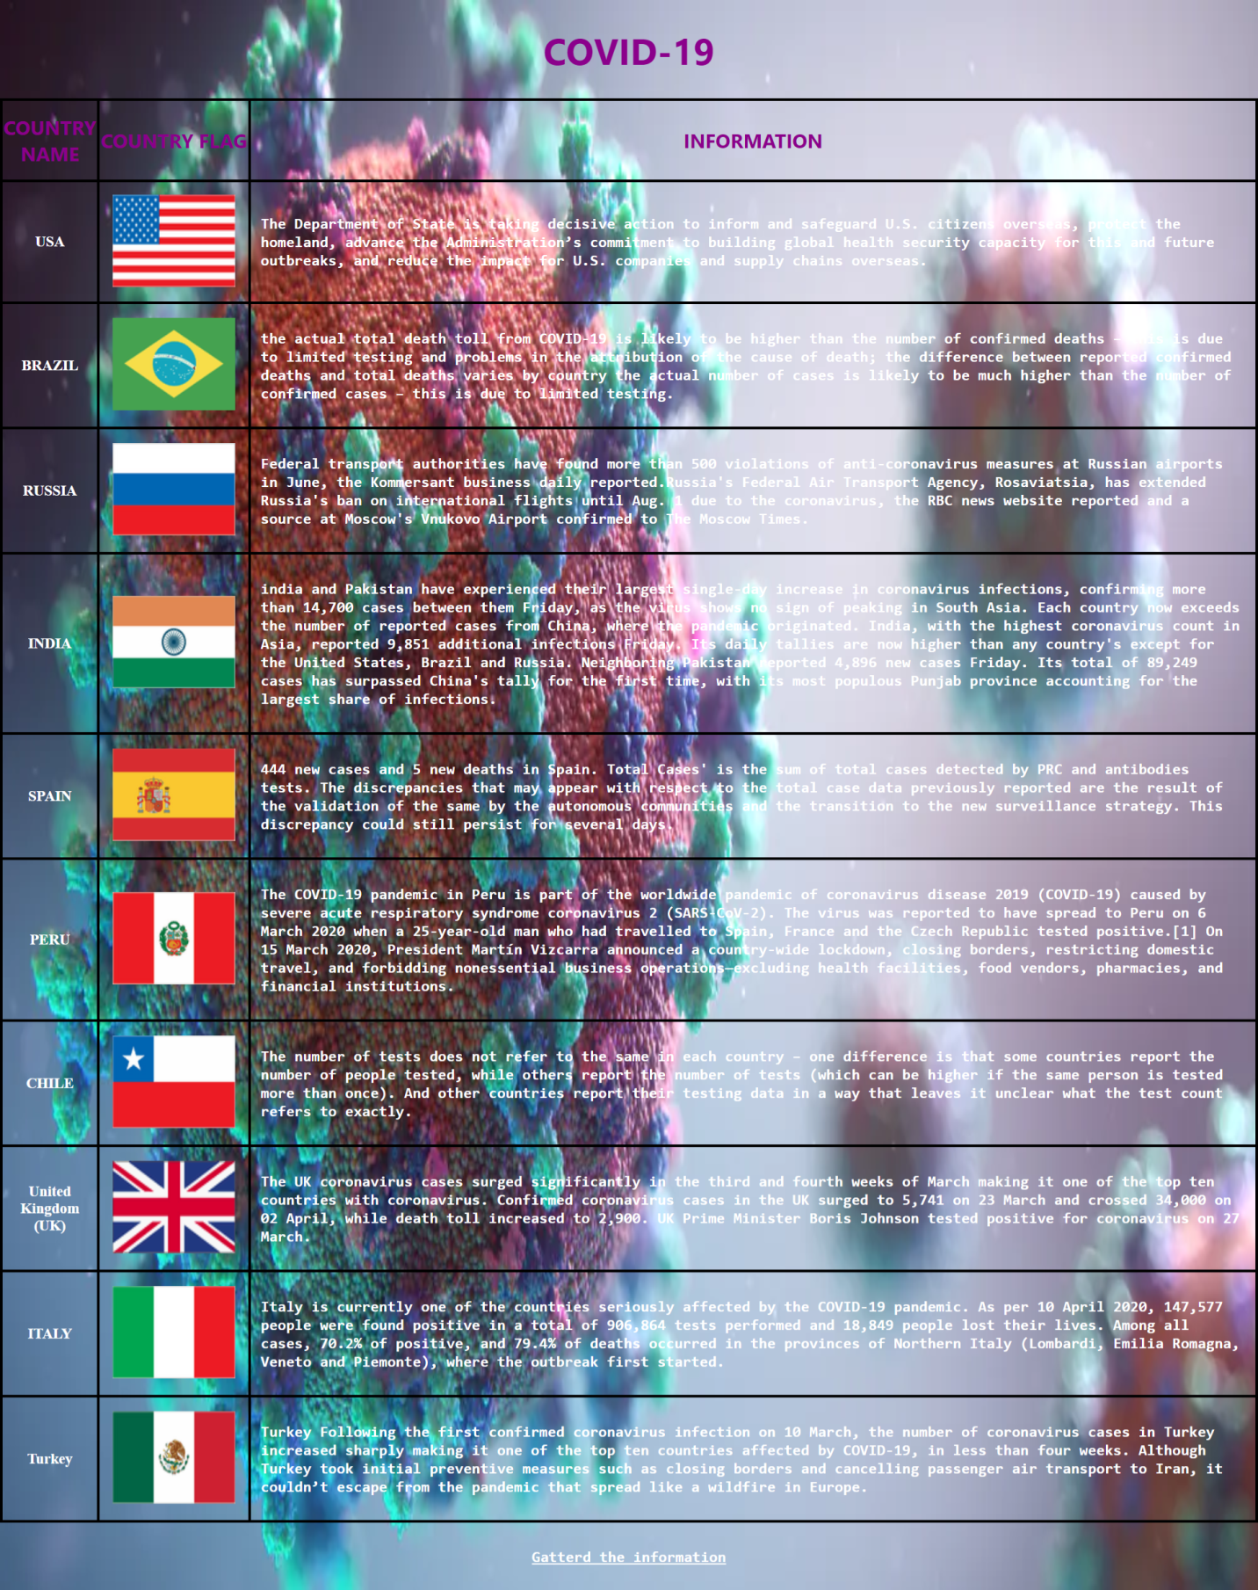

**Question 4:** Create a webpage form using JavaScript. Ask the user their name, gender, and age. Once the user enters the fields, the program should display the username and greet them. For e.g. “Hello John”.

**( ____ / 5 marks)**

**Write your code here:**

**<!DOCTYPE html>**

**<html lang="en">**

**<head>**

**<meta charset="UTF-8">**

**<meta name="viewport" content="width=device-width, initial-scale=1.0">**

**<title>Document</title>**

**</head>**

**<style>**

**#Name**

**{**

**font-family: Verdana, Geneva, Tahoma, sans-serif;**

**}**

**#gender**

**{**

**font-family: Verdana, Geneva, Tahoma, sans-serif;**

**}**

**#age**

**{**

**font-family: Verdana, Geneva, Tahoma, sans-serif;**

**}**

**#Name::placeholder**

**{**

**font-family: Verdana, Geneva, Tahoma, sans-serif;**

**}**

**#gender::placeholder**

**{**

**font-family: Verdana, Geneva, Tahoma, sans-serif;**

**}**

**#age::placeholder**

**{**

**font-family: Verdana, Geneva, Tahoma, sans-serif;**

**}**

**</style>**

**<body style="background-color: cornflowerblue;">**

**<center><u><i><h1 style="font-family: Comic Sans MS, cursive, sans-serif;">Enter Your Name,Gender & Age</h1></u></i>**

**<form>**

**<input style="height: 50px; width: 20%;border-radius: 20px; padding-left: 10px;" type="text" id="Name" placeholder="Enter your value: "><br><br>**

**<p id="validate1" style="font-family: 'Times New Roman', Times, 'Franklin Gothic Medium', 'Arial Narrow', Arial, sans-serif; color: red;font-size: small;margin: 0px;"></p>**

**<input style="height: 50px; width: 20%;border-radius: 20px;padding-left: 10px" type="text" id="gender" placeholder="Enter your gender: "><br><br>**

**<p id="validate2" style="font-family: 'Times New Roman', Times, 'Franklin Gothic Medium', 'Arial Narrow', Arial, sans-serif; color: red;font-size: small;margin: 0px;"></p>**

**<input style="height: 50px; width: 20%;border-radius: 20px;padding-left: 10px" type="number" id="age" placeholder="Enter your age: "><br><br>**

**<p id="validate3" style="font-family: 'Times New Roman', Times, 'Franklin Gothic Medium', 'Arial Narrow', Arial, sans-serif; color: red;font-size: small;margin: 0px;"></p>**

**<input style="border-radius: 20px;background-color: aqua;height: 40px; font-family: Impact, Haettenschweiler, 'Arial Narrow Bold', sans-serif;width: 100px;" type="button" onclick="values()" value="Click Here!">**

**</form>**

**<p id="demo" style="font-family: 'Times New Roman', Times, serif; color: blue; font-size: 20px;"></p>**

**</center>**

**</body>**

**<script>**

**function values()**

**{**

**var value1 = document.getElementById("Name").value;**

**var value2 = document.getElementById("gender").value;**

**var value3 = document.getElementById("age").value;**

**if(value1 == "")**

**{**

**document.getElementById("validate1").innerHTML="Enter Name";**

**}**

**else if(value2 !== "male" && value2 !== "female")**

**{**

**document.getElementById("validate2").innerHTML="Enter male or female";**

**}**

**else if(value3<=0)**

**{**

**document.getElementById("validate3").innerHTML="Enter age greater than 0";**

**}**

**else if(value1 != "" && value2!= "" && value3!= "" )**

**{**

**document.getElementById("validate1").remove();**

**document.getElementById("validate2").remove();**

**document.getElementById("validate3").remove();**

**document.getElementById("demo").innerHTML="Hello "+value1+"";**

**}**

**else{**

**document.getElementById("demo").innerHTML="Enter all values";**

**}**

**}**

**</script>**

**</html>**

**Paste a snapshot of your webpage here:**

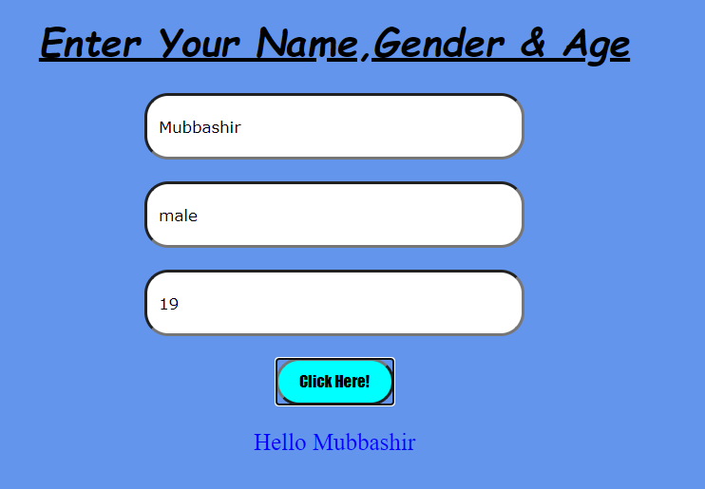

**Question 5: Choose (highlight) the appropriate answers:**

**( ____ / 10 marks)**

1. To achieve the sum of two numbers through user input in Python, which of the following statements are incorrect.
2. num2 = input(“Enter first no.”); num1 = input(“Enter Second no.”);
3. num1 = int(“Enter first no.”); num2 = int(“Enter Second no.”);
4. num1 = float(input(“Enter first”)); num2 = int(input(“Enter second”));
5. option a & b
6. option a
7. Internal CSS is different from inline CSS because:
8. Both require different languages
9. Internal CSS requires a different file
10. Internal CSS require separate tags
11. Which of the following Logic Gate is equivalent to a multiplier?
12. AND Gate
13. OR gate
14. XOR Gate
15. NAND gate
16. Write a Python code that creates a list of 5 elements and then arranges them in an order

**Write your code here:**

**arr = []**

**num = int(input("Enter number of elements : "))**

**for i in range(1, num+1):**

**element = str(input("Enter %d number: " % i))**

**arr.append(element)**

**print(sorted(arr))**

**THE END**